Abdul Basit

193227

BSCS-6B

Lab 06

# 1 Code:

from PIL import Image

from PIL import ImageOps

import cv2

import numpy as np

from matplotlib import pyplot as plt

def main():

#OPENING IMAGE

img = Image.open("image.jpg")

#CREATING NUMPY ARRAY

imageArray = np.array(img)

#CALCULATING HISTOGRAM USING OPENCV

histogram = cv2.calcHist([imageArray],[0],None,[256],[0,256])

plt.hist(imageArray.ravel(),256,[0,256])

#PLOTTING IT ON X-Y XIS

plt.show()

#EQUALIZING IMAGE

equalizedImage = ImageOps.equalize(img)

#CREATING ARRAY OF EQUALIZED IMAGE

imageArray1 = np.array(equalizedImage)

histogram = cv2.calcHist([imageArray1],[0],None,[256],[0,256])

#PLOTTING HISTOGRAM

plt.hist(imageArray1.ravel(),256,[0,256])

#SHOWING IMAGE ON PLOT

plt.show()

#SHOWING IMAGE IN WINDOW

equalizedImage.show()

#SAVING IMAGE

equalizedImage.save('image.jpg')

#CALLING IF MAIN FUNCTION EXISTS

if __name__=="__main__":

main()

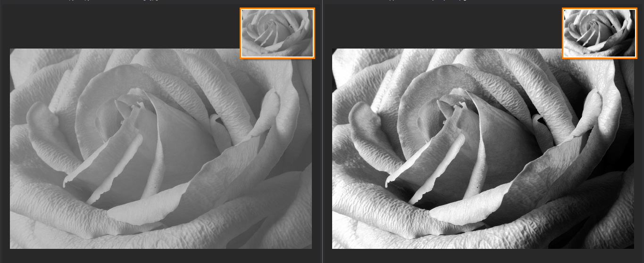

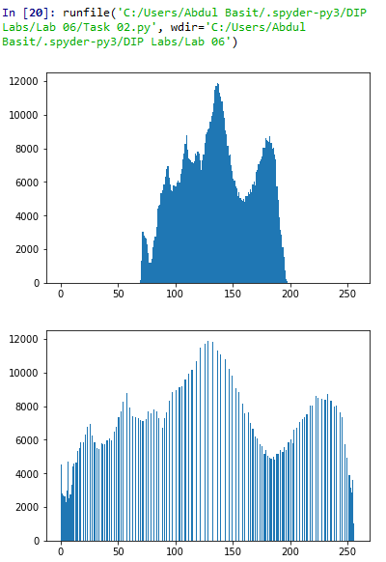

**2 Code:**

from PIL import Image

import numpy as nm

from matplotlib import pyplot as plt

def main():

#OPENING IMAGE IN GRAY SCALE

img = Image.open("image.jpg").convert("L")

#CREATING NUMPY ARRAY

imageArray = nm.array(img)

#EXTRACTING PARAMETERS

rows = len(imageArray)

colomns = len(imageArray[0])

#NUMPY ARRAY

imageArray1 = nm.zeros(imageArray.shape, dtype = int)

#NESTED LOOPS TO APPLY POWER LOG METHOD

for x in range(rows):

for y in range(colomns):

#ENHANCING IMAGE

imageArray1[x][y] = pow(imageArray[x][y],1.05)

#SHOWING IMAGE IN WINDOW

Image.fromarray(imageArray1).show()

#CALLING IF MAIN FUNCTION EXISTS

if __name__=="__main__":

main()

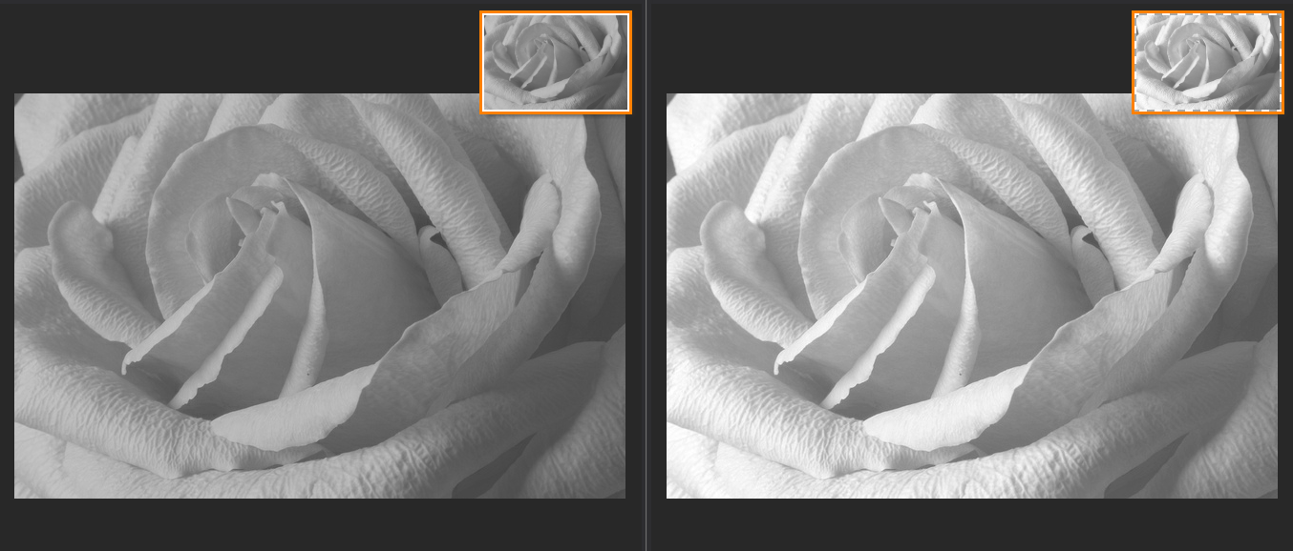

END